Chapter 19, Solution 17.

To obtain 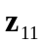 and 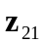, consider the circuit in Fig. (a).
I₂ = 0
16 
8 
4 
+
V₁
−
I₁
(a)
+
V₂
−
I_{o}'
I_{o}
12 

In this case, the 8- and 16- resistors are in series, since the same current, 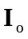, passes through them. Similarly, the 4- and 12- resistors are in series, since the same current, 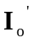, passes through them.

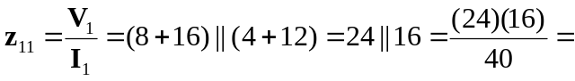9.6 Ω

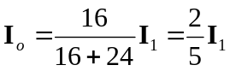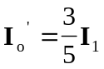

But 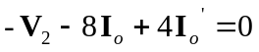
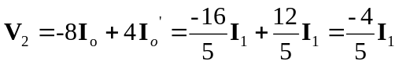
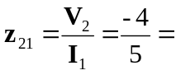 –0.8 Ω
To get 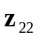 and 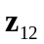, consider the circuit in Fig. (b).
I₂
I₁ = 0
16 
8 
4 
+
V₁
−
(b)
+
V₂
−
12 

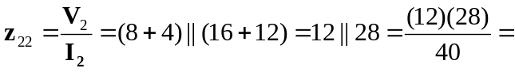 8.4 Ω

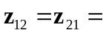–0.8 Ω

Thus,
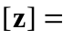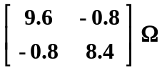

We may take advantage of Table 18.1 to get [y] from [z].
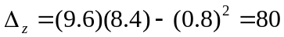
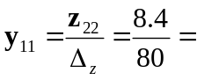 0.105 S 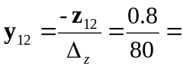0.01 S
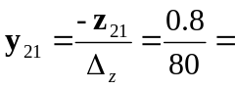0.01 S 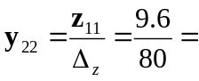0.12 S

Thus,
